 | 26.9.14 Editors - Properties Editor - Modifiers Properties Tab - Lattice - Modify modifiers
Table of content
Detailed table of content 1
Lattice - Modify modifiers 1
Mesh Cache 1

Detailed table of content
Detailed table of content
Detailed table of content 1
Lattice - Modify modifiers 1
Mesh Cache 1
Format 2
File Path 2
Influence 2
Deform Mode 2
Interpolation 2
Time Remapping 2
Frame / Time / Factor 2
Play Mode 2
Frame Start 2
Frame Scale 2
Axis Mapping 2
Forward/Up Axis 2
Flip Axis 3

Lattice - Modify modifiers

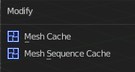

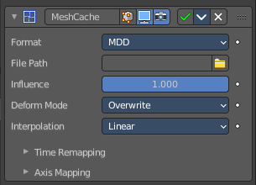
Mesh Cache
The Mesh Cache modifier allows you to apply animated mesh data to a mesh. And deform it when playing back.
This works in a similar way to shape keys. But uses external files, and allows to interchange between applications.
Tip! Both MDD and PC2 depend on the vertex order on the mesh remaining unchanged. This is a limitation of this method, so take care not to add/remove/reorder vertices once this modifier is used.

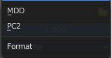
Format
The input file format (currently .mdd and .pc2 are supported).

File Path
Path to the cache file.

Influence
Factor to adjust the influence of the modifier’s deformation.

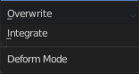
Deform Mode
This setting defaults to Overwrite which will replace the vertex locations with those in the cache file.
When you want to mix a mesh cache file with shape keys, then you can select the Deform option which integrates deformations with the mesh cache result.
Note that this feature is limited to making smaller, isolated edits and will not work for larger changes such as re-posing limbs.

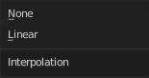
Interpolation
The blend mode between frames. Use linear when the frames in the cache file do not match up exactly with the frames in the blend-file.

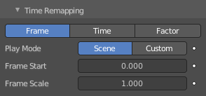
Time Remapping

Frame / Time / Factor
How time is calculated.

Play Mode
How playback operates.

Frame Start
Play the cache starting from this frame.

Frame Scale
Scale time by this factor (applied after the start value).

Axis Mapping

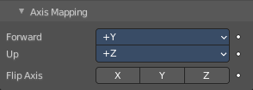
Forward/Up Axis
The axis for forward and up used in the source file.

Flip Axis
Allows you to flip the coordinates on an axis.

